I list all corrections according the page in which they are referenced in the LaTeX document. If anything remains unclear please let me know!

Pg 11 - Regarding claims about IPCC reports on water scarcity -- taken from Section 3 “Climate change and its impacts in the near and long term under different scenarios” - specifically page 49. These claims are based on climate modeling projects are reported with “high” to “very high confidence”.

<http://www.ipcc.ch/publications_and_data/ar4/syr/en/spms3.html>

Pg 13 - Regarding claims about the impact of climate change on the Canadian fishing industry.

We could change the statement “For instance, there is general consensus amongst fisheries scientists that the changing climate is going to significantly impact the Canadian fishing industry” to something like the following, based on the source document:

-The XXX reports that climate change is going to have significant impacts on Canadian coastal zones and on Canadian fisheries operating in these regions. Projected impacts include damage to coastal infrastructure, increased property loss, higher risk of disease amongst fish populations, increased flood risks and corresponding loss of life, and loss of cultural resources (Summary, xvii).

Source: Government of Canada, *Climate change impacts and adaptation: A Canadian perspective*. 2004. Available at http://www.glisa.umich.edu/great_lakes_climate/docs/Climate-Change-Impacts-and-Adaptation-a-Canadian-Perspe Environment Canada. 2011b. National Inventory Report: Greenhouse Gas Sources and Sinks in Canada 1990-2009ctive.pdf

Pg. 14 -- Regarding the citation included in footnote to Environment Canada 2011b. I also have no idea why this is there!! I think it’s okay to erase.

Pg. 14 -- Regarding the citation for the fact of 785 catastrophes per year and 950 natural disasters. For some reason the reference is wrong here. The correct source is:

Munich Re, January 3, 2011: *Overall Picture of Natural Catastrophes in 2010 – Very Severe Earthquakes and Many Severe Weather Events*. Accessed online at [http://www.munichre.com/en/media_relations/press_ releases/2011/2011_01_03_press_release.aspx](http://www.munichre.com/en/media_relations/press_%20releases/2011/2011_01_03_press_release.aspx).

Pg 14 - Regarding the citation “(Environment Canada, ND)”. The ND stands for *no date,* because it refers to a general website with no year of publication referenced. However, the corresponding citation in the bibliography has the wrong title. It needs to be changed from:

Environment Canada. Canada’s **Domestic Action**. Available from http://www.climatechange.gc.ca/default.asp?lang=En&n=4FE85A4C-1

to:

Environment Canada. Canada’s **Action on Climate Change**. Available from http://www.climatechange.gc.ca/default.asp?lang=En&n=4FE85A4C-1

Pg. 15 - Regarding the need for sources for the following statement:   
“In Canada, temperatures have warmed at an average pace of 0.24°C per decade, as indicated by data dating from the first official records of weather conditions in 1948 through to 2010. This figure represents twice the global average, with temperature rises in the far north occurring at rates three times faster. The average national temperature in 2010 reached 3.0°C above normal, making it the hottest year on nationwide records”.

The claims should be referenced to the following source, already included in the bibliography:

Institute for Catastrophic Loss Reduction (ICLR) *Telling the Weather Story.* for Insurance Bureau of Canada (IBC) July 2012.

Page 5 for the particular facts referenced above.

Pg 15 - Regarding “Figure X” -- shown below:

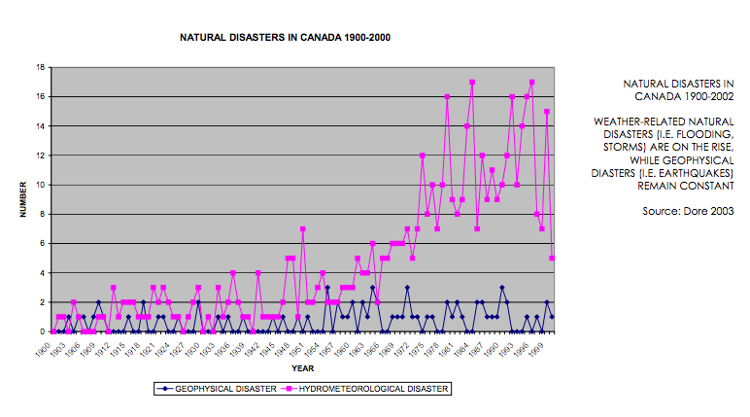

Source: Dore, M. (2004). ʺForecasting the Conditional Probabilities of Natural Disasters in Canada as a Guide for Disaster Preparedness.ʺ *Natural Hazards,* 28: 249-269.

Pg. 15 Regarding the citation needed for “These are contrasted to the number of geophysical…”

Source:

WieditzPenney_2006 = Wieditz, I. and Penney, J. (2006). *A Scan of climate change impacts on Toronto*. Clean Air Partnership: Toronto. http://www.cleanairpartnership.org/pdf/climate_change_scan.pdf

Page 8 for the particular facts referenced above.

Pg. 17 - Regarding a source citing the figure of 140,000 deaths per year (is this the figure that you couldn’t find? I’m not sure if I’m interpreting this comment correctly).

You can find this figure here: <http://www.who.int/mediacentre/factsheets/fs266/en/>

Pg. 18 - Regarding the quote “… diarrhea and other digestive ailments, malnutrition, and malaria, are “highly climate-sensitive and are expected to worsen as the climate changes”.

This can be changed to

As detailed on the WHO webpage, a number of the fatal diseases already affecting these populations, such as diarrhea and other digestive ailments, malnutrition, and malaria, are “highly climate-sensitive and are expected to worsen as the climate changes” “Climate change and health”, 2012).

Source:

World Health Organization. (October, 2012). *Climate change and health.* Available at: <http://www.who.int/mediacentre/factsheets/fs266/en/>

Pg. 18 Regarding the sources that require more documentation details:

Costello, A., Abbas, M., et al., 2009. Managing the health effects of climate change.

Lancet 373, 1693–1733.

CSDH (2008). *Closing the gap in a generation: health equity through action on the social*

*determinants of health*. Final Report of the Commission on Social Determinants of Health.

Geneva, World Health Organization. Available at : <http://whqlibdoc.who.int/publications/2008/9789241563703_eng.pdf>

I left out the Global Forum for Health reference.

SUGGESTED ADDITIONAL REFERENCE

I came across this paper while correcting these references and thought it would be a useful addition to the “Threads to indigenous cultures” section-- the article underscores the point that climate change effects will result in “signiﬁcant heterogeneity in health outcomes, and health inequality is particularly pronounced among Aboriginal Canadians” (p. 1).

Ford, J.D., et al., *Vulnerability of Aboriginal health systems in Canada to climate change.* Global Environ. Change (2010), doi:10.1016/j.gloenvcha.2010.05.003 Available at: http://www.jamesford.ca/wp-content/uploads/2010/06/in-press-version.pdf